Setting up the ATMEGA16 Programmer and Debugger
Hardware Modifications 21 August 2019
On the Atmega16 Debugger board is necessary to replace R1 and R2 by 0R resistors (wire), because the voltage levels are protected using the level translator on MC board.
On the MC is NOT necessary to put C5 to Vcc, as it is now to GND works good.
Firmware
1) Check the fuses and write as the following image.
L = 0xFF
H = 0xD9
E = 0xF7
LB = 0xFF <- Maybe this is not necessary to write.
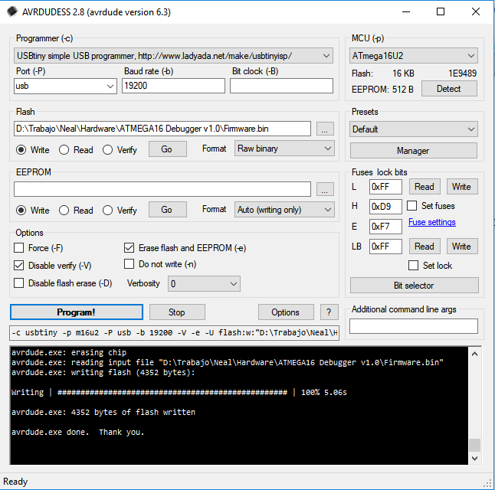
It is important to check the Erase Flash and EEPROM option.
(NB: Programmer setup may vary – check the following pics of the options)

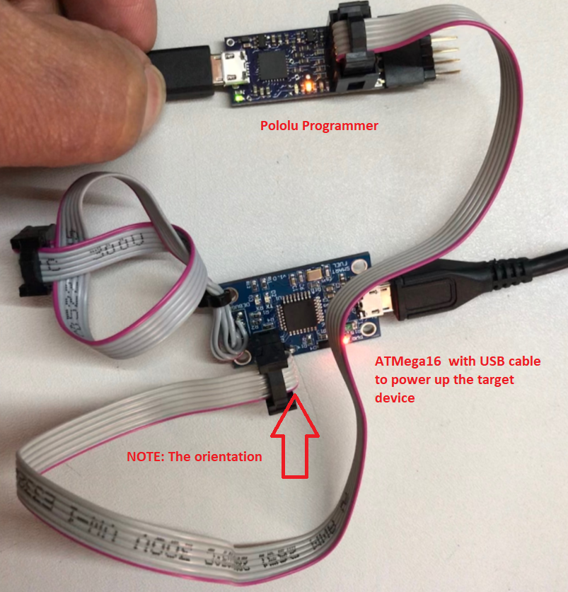
This is the setup for the Pololu Programmer which is used to program the MID as Well.
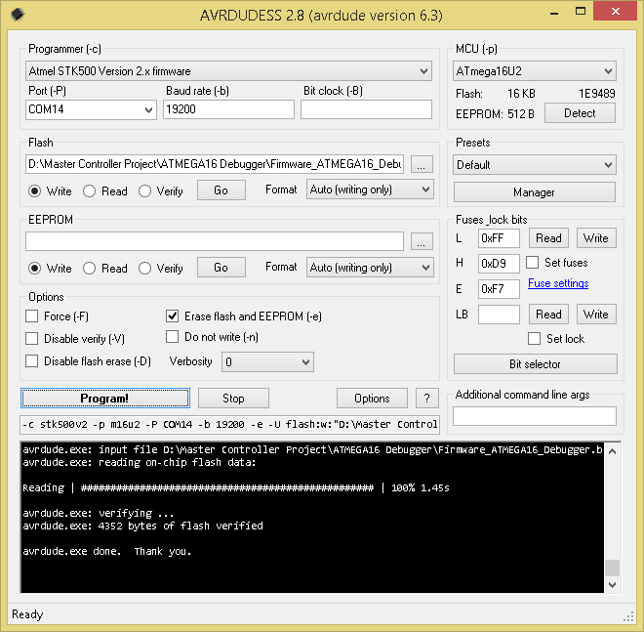
Use the firmware file Firmware_ATMEGA16_Debugger.bin

Hardware Connection (correction of design error)

On the left is the debugger and in the right is MC. There supposed to be a number to number but that is not possible and another solution was required
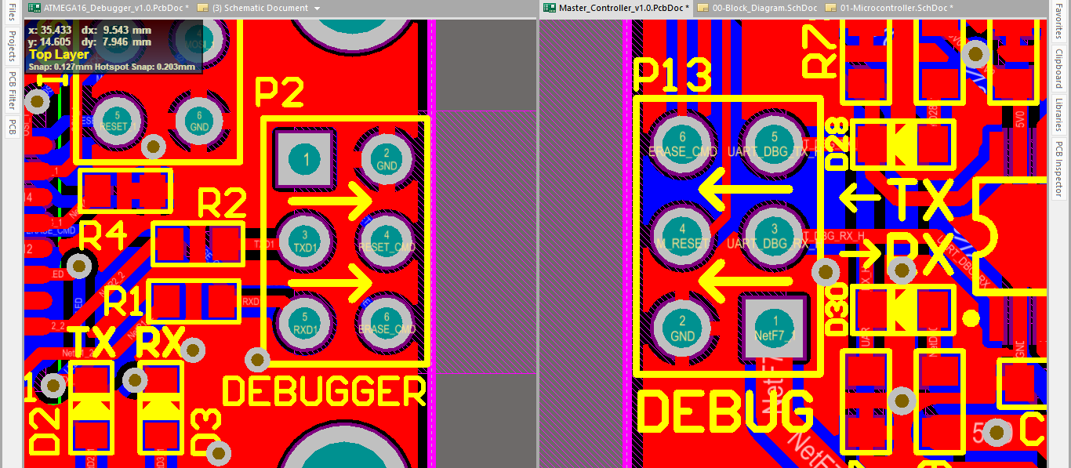
By soldering the wire positions 1 to 6 on the ATMEGA board, the problem has been solve for this versión of the ATMega16.
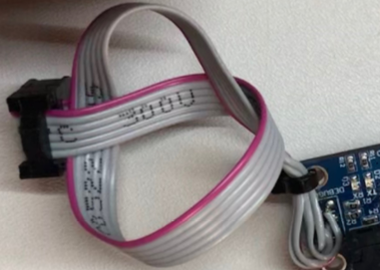

Connection and precautions

Right sequence of connecting:
1) Connect the Debugger to PC
2) Power on the MC
Right sequence of disconnecting:
1) Power off the MC
2) Disconnect the Debugger from PC
If you dont follow the previous steps for connecting and disconnecting, the Debugger can erase the firmware on MC. Because the Erase line is connected and a low in this line erase the memory of MC if it is powered.

The Programming Setup and debug Console view

