The MID Digital Pump Setup
With Switch position #5 on SW1 Set, Uart1 will use the settings of Uart2, this would mean that the Tagging will use the native baudrate of the Pump.
Alternately, with Switch position #5 on SW1 in the OFF position, the Pump and Tag will be configure for the 9600,8,N,1 and the native baud conversion occurs in the MID.

Testing with the SM 2000 Pump
Test1 with SW1 position #5 = OFF / SW2 position #1-3 = 010
SM2000 and SFTDual Tagging Baud rate = 9600,N,8,1
Firmware Version: V1.0.8
Results: The SM2000 came online when the Slide switch was moved to the T (Tokheim) Position. Must keep the unused Pump port to the L (Loop) position.
Test2 with SW1 poistion #5 = ON / SW2 position #1-3 = 010
SM2000 and SFTDual Tagging Baud rate = 4800,E,8,1
Firmware Version: V1.0.8 failed to communicate to the Pump- This is bug.
Firmware Version V0.3.6 worked well.
Please note the peculiarities of the legend that will be correctly in the next revision.
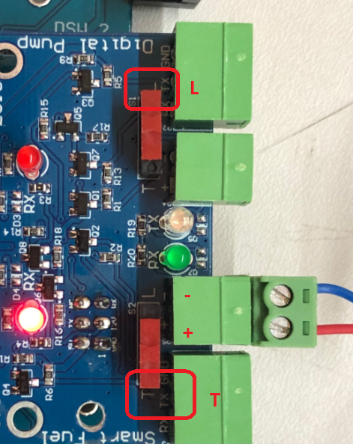

Other Observations
The receive LED on the MID stays red and the two Tx Rx LEDs on the Digital DB did not come on.
This would require some investigation.

