Master Controller – Programming the MC with the ATMEGA16 Debugger
Here the changes to the ATMEGA16 Device
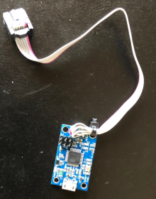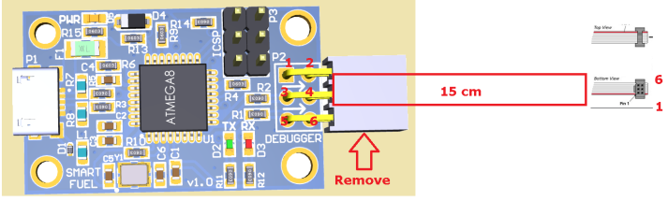

How to Program with it
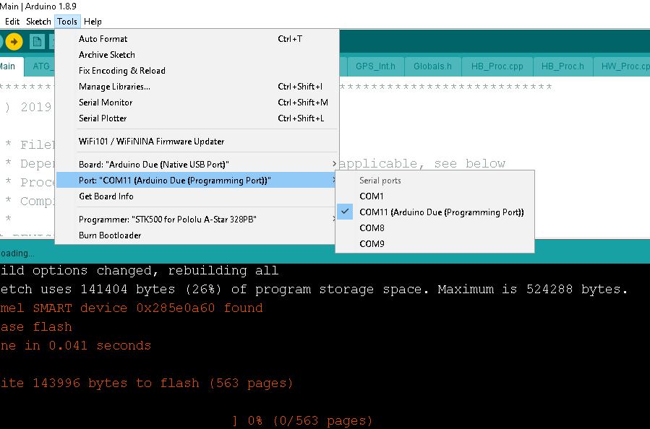

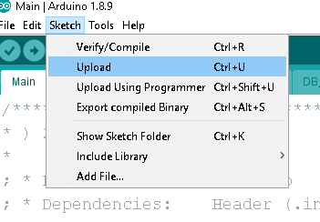

NB: The serial monitor can be used directly to view the Debug data

