Master Controller – RS 485 Connections #1
Connecting the MID to the USB RS458 adapter
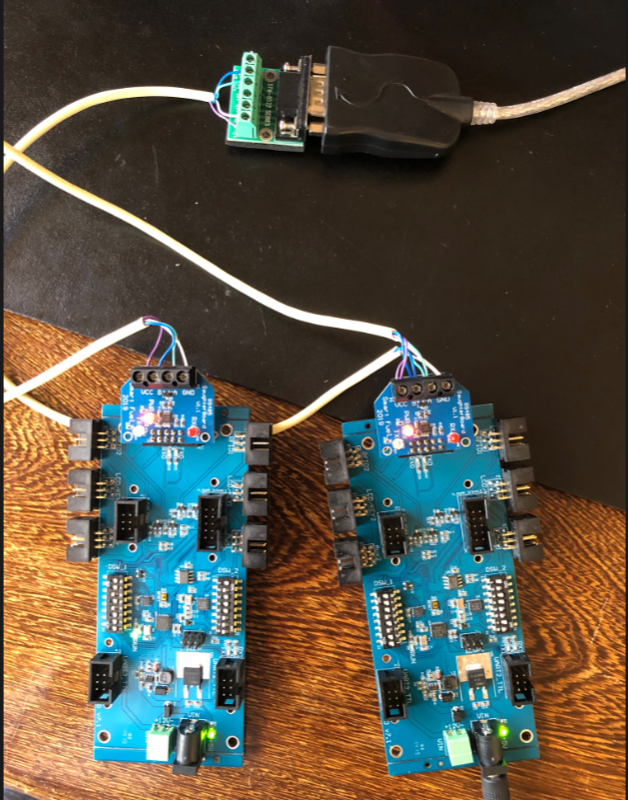
All the marking are connected A to A and B to B. The Power(+12V) and Ground (GND) is required on the RS485 adapter as well as the MID. In this picture above, the MID is powered and via the RS485 daughter board’s +12V and GND connections the other MID and the RS485 Adapter is powered.

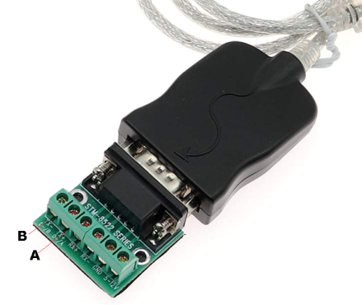
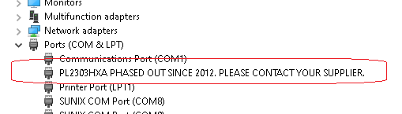
This is the message was displayed on the Device Manager – it is misleading as the device works fine.
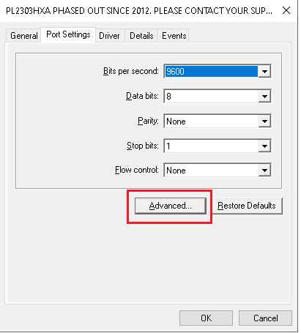
Right click on Properties and Go to the Advanced

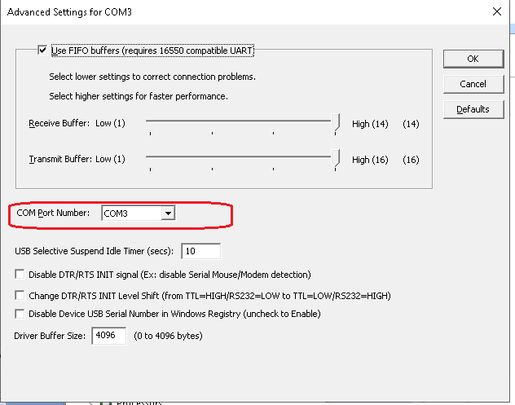
This is the Com port number that you can use in the Pump configuration

