MySQL Workbench Setup
Install: mysql-installer-web-community-8.0.17.0.msi
Once the MySQL Workbench is loaded, you can run it
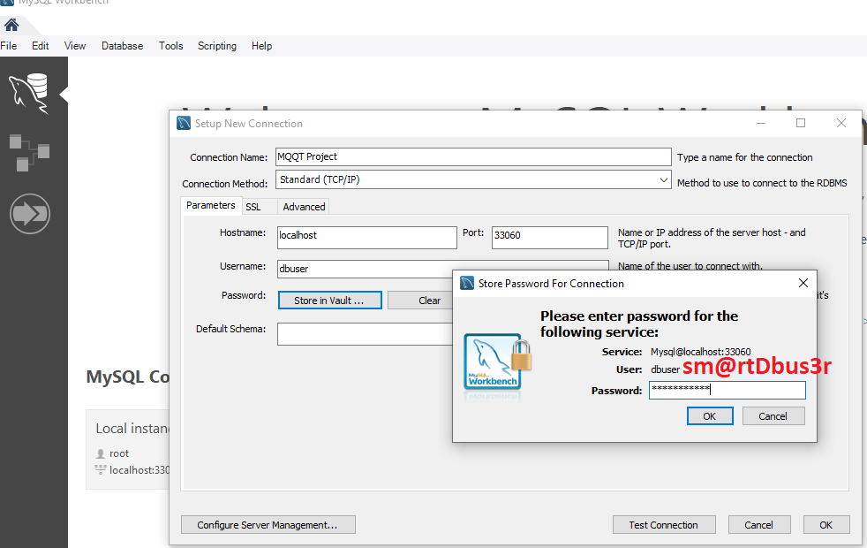
Open the tunnel to the Linux Server

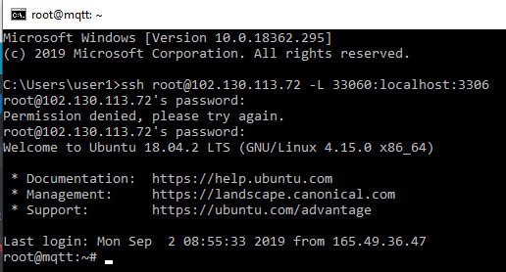
ssh root@102.130.113.72 -L 33060:localhost:3306
password: sm@rtR3dmqtt

