Master Controller Generator ON /OFF Detection

PIN4 on P16 pulled to ground changes the state of the Generator

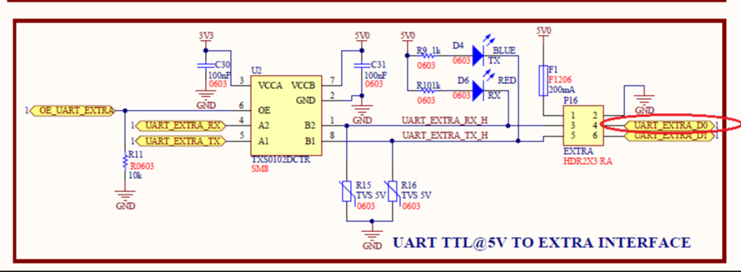

This gets reported on the ATG heartbeart Future field – which will be later renamed to EVENTS (0x80)
The most significant bit is the Generator Mode.
If the Pin4 is High = Generator OFF (MSB = 0)
If Pin4 is pulled to ground = Generator ON (MSB=1)

