How to determine Volume of Fuel from the Height
Back Ground
There are essentially two types of readings from the ATGs that we are working with;
- The Level Reading – which is the height of the Fuel, which could be determined by means of a fuel float (e.g. Tokheim, Veederoot) or an Ultrasonic measurement (e.g. B-ULM)
- The Distance Reading – which is the Distance from the sensor mounted at the Top of the Tank (using raised on a special tube) to the surface of the fuel (e.g. A-ULM)

This picture shows the two types and for the A-ULM (Distance Type) – to get the Fuel Level, you would need to take the height of the Vessel and minus the Distance Reading.
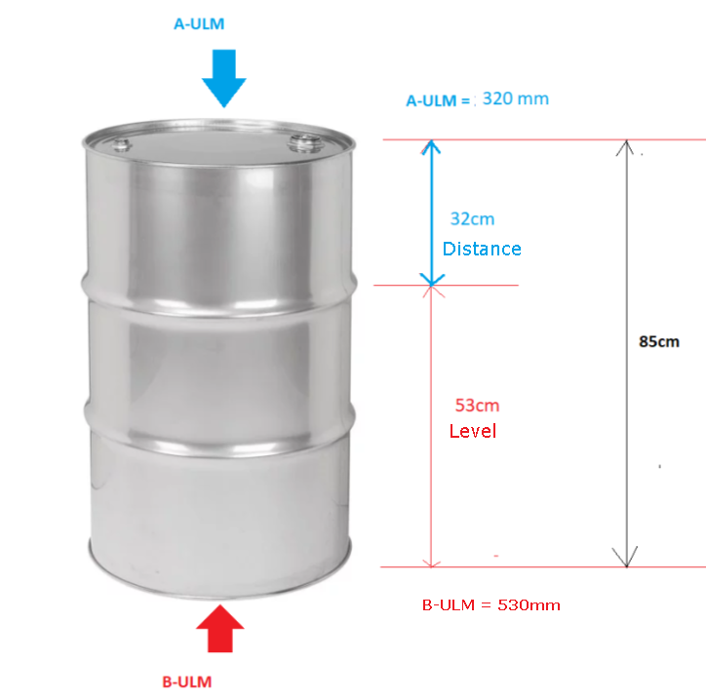

Now it is important to understand the BlindArea with regards to the A-ULM sensor. The A-ULM device cannot accurately detect fuel level if its within it BlindArea, so to solve this, the Sensor is raised on tube so Fuel cannot enter that area.
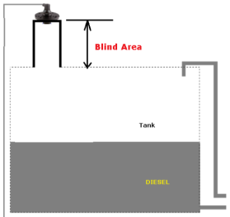
As a result, you can see the distance to the Fuel from the sensor is now increased by the size of the Blind Area.

The Calculation of the Volume

Once the Raw Height of the Fuel is received from the MC_heartbeatATG, this is the sequence of action;

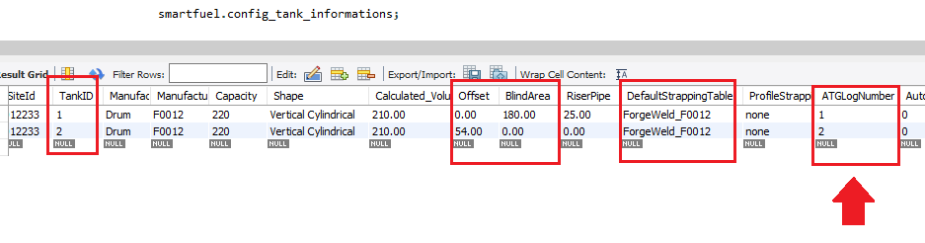
- Determine the type of reading (Distance or level) and to do this, go to the Config_Tank_informations table and find the ATGLogNumber.
- From the ATG logical number, you need to find the type of ATG that is being use and we have created codes for each type.
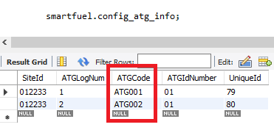

- From the ATGCode, we can now determine the specifics about this device and this is gotten from Setup_ATG_Make Table and the important data is the MeasurementMode and to know which readings is gotten from each ATG Type (i.e. Temperature and ProductHeight is only available).
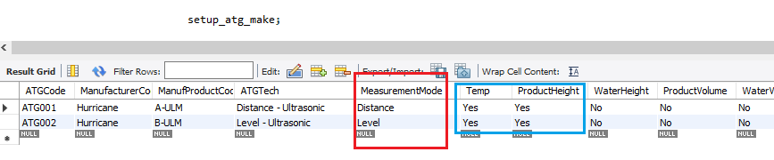

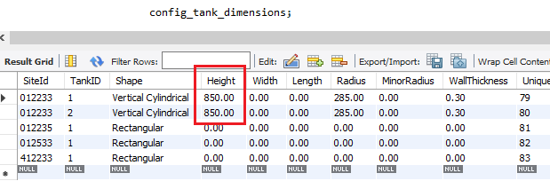
- Now Distance requires a special calculation as discussed earlier and to know the Height of the Tank, you go to a Table that was created so that the volume could be determined by mathematical calculations instead of the Strapping Table. We are only interested in the Height as this time from the Config_Tank_Dimensions Table;

Now from the Distance we can determine the Corrected “Height” of the Fuel is determined as follows;

DISTANCE (A-ULM) Formula to find the Actual Fuel Height

Actual Fuel Height = Tank Height (Config_Tank_Dimensions) minus [Distance : Raw Height (MC_HeartBeatATG) minus BlindArea(Config_Tank_informations) plus OffSet]
NB: The OffSet never applies so in this case will be ZERO, but it can be left out all together.

- Formula for Level Type ATGs

LEVEL (B-ULM, Tokheim, Veederoot) Formula to find the Actual Fuel Height

The LEVEL type ATGs gives a Fuel Height, but there might be a need for an OffSet should the Probe require some sort of calibration or the Probe does not reach the bottom of the tank.

Actual Fuel Height = Raw Level (MC_HeartBeatATG) plus OffSet

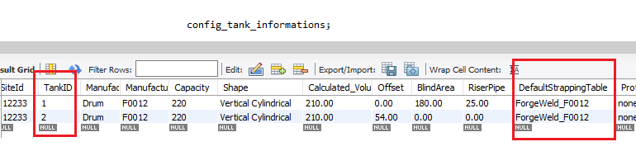
- Now that the Actual Fuel Height is known, that figure needs to be converted to a Volume and this where the DefaultStrappingTable name is needed
The Config_tank_Strapping_Default table will give a range of readings that you would need find the closest pair of readings that the Height fits between and the extrapolate the volume.
NB: in this crude example only the lowest and highest values are given – this will not work for a Horizontal Cylinder.
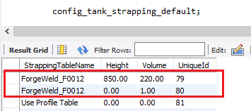

- The Water Height only applies to the Veederoot and Tokheim (Start Italiana) Type ATGS. The OffSet will still need to be added to the Height of the Water to determine the volume.

NB: Logic would suggest that the Volume of the Fuel is being propped up by the Volume of the Water and when representing the Volume, the amount of water in the Tank will need to be removed to give the actual Fuel in the Tank. This will apply to the Web/Mobile App in the case of those ATGs only.

