How to Program the MID with a Pololu Adapter
Once the Fuses are down and you need to program the MID
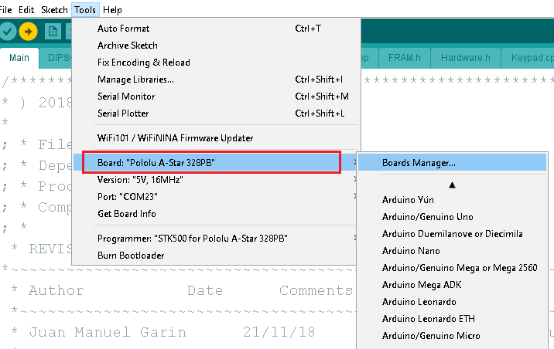

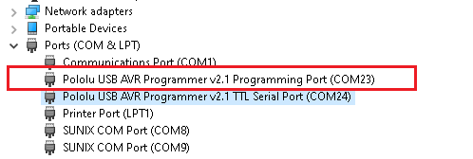

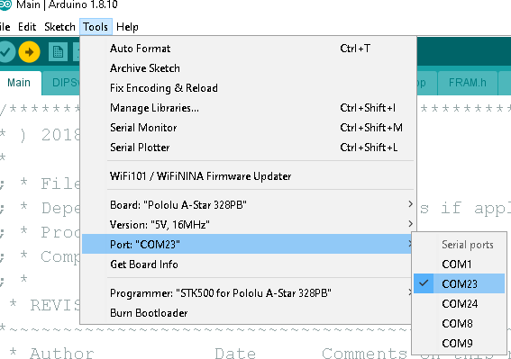

The Cables on the Pololu adapter are not standard so use this picture orient the adapter
