SMARTFUEL SYSTEMS
29 COOPER STR, CYRILDENE, GAUTENG

Technical Directive

20 November 2019

Manufacturing Staff
Technicians
QUAL STAFF
Stores

Testing the B-ULM ATG (Ultrasonic Level Sensors)

Hurricane have sent us the wrong configured stock on all orders of the A-ULM device. In fact, in the last order they sent us TTL devices instead of RS485.
It important that all stock be tested before it is put on the shelf or shipped to a job.
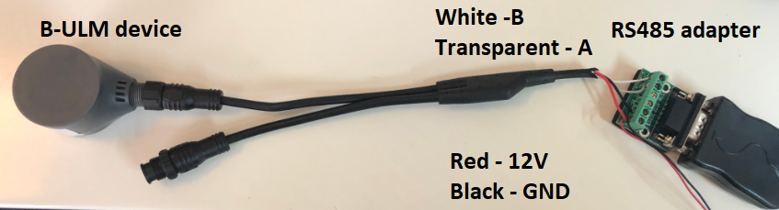
A quick and simply test via MPC (9600,8,N,1) checking that the temperature value is valid.
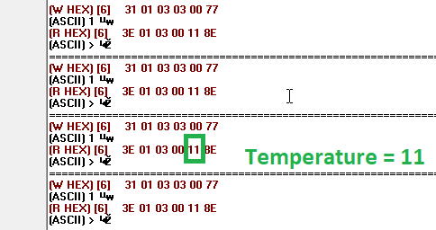
You can quickly swap out and test the next device once you see the expect value. NB: It will not always be 11 degrees. It took less than a minute to test all 8 devices.
Qual must setup a TestJig so that this test can be done by Stores with minimal setups.
CEO
(Qual HFA)

