SMARTFUEL SYSTEMS
29 COOPER STR, CYRILDENE, GAUTENG

Technical Directive

20 November 2019

Manufacturing Staff
Stores
QUAL STAFF

Securing the B-ULM / B2-ULS Magnetic on the Holder

There is an optional holder that goes with the B-ULM /B2-ULS (Bottom Ultrasonic Sensors) and it has magnets that fall out of its intended location.
These need to secured with Glue so that they stay in place and to ensure that the Magnets are in the correct place once glued, use a flat sheet of metal that will pull the magnets home.

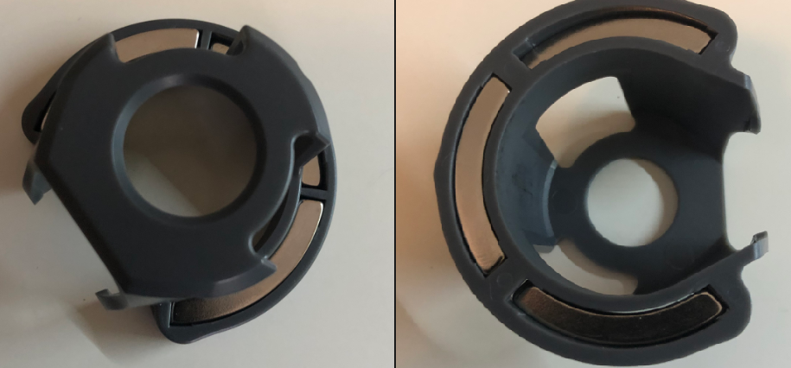

CEO
(Qual HFA)

