Fuel Transaction Acknowledgement 19 Dec 2019
PURPOSE: ACK is sent to the MC to indicate that the Server successfully received the Transaction. If the MC did not get the ACK, after 10 Secs it will resend the Transaction. The MC_Server must be guarded against duplicate transactions

Detailed Description
When a transaction is received at the MC_Server, an Ack must be sent back to the MC with the same command and same MsgNum and the Transaction number in the Payload

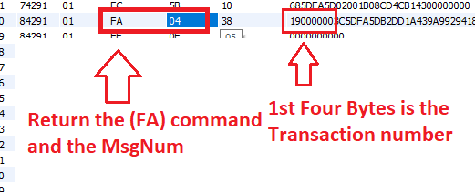

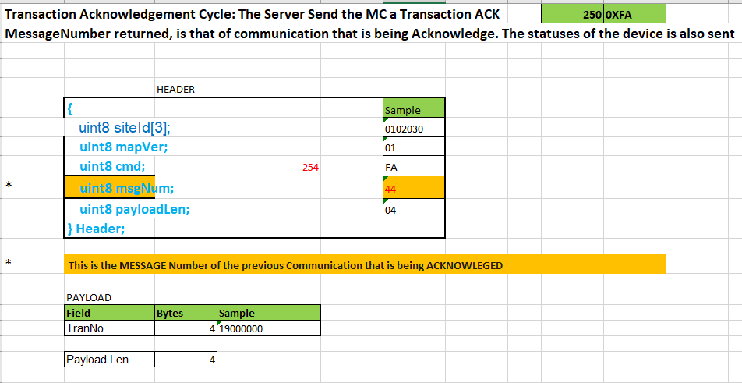

This was done and here is the result in the Debug Console
