Master Controller Hatting Series Rejection Report
The Rejection report populates the unknown Tag into the Second Tag field. The Vehicle Tag field will hold the Tag that a second tag failed as part of a Fuelling Sequence. In that case it could be the Attendant or Driver Tag.
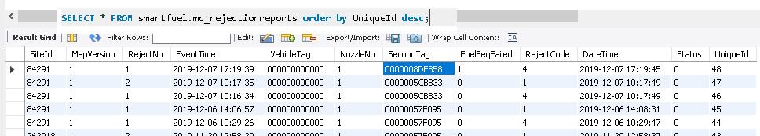
The RejectNo is a sequential number that counts up for each rejection and the FuelSeqFailed give the Step# in the Fuel Sequence that failed. The Reject Code is as follows;
REJECTION CODE_TIMEOUT 1
REJECTION CODE_ACC_LIMIT 2
REJECTION CODE_TAG_LIMIT 3
REJECTION CODE_UNKNOWN_TAG 4
REJECTION CODE_PIN_FAILED 5
REJECTION CODE_KM_LIMIT_FAILED 6
REJECTION CODE_HR_FAILED 7
REJECTION CODE_WRONG_FUELGRADE 8
REJECTION CODE_WRONG_FUELTYPE 9
REJECTION CODE_FIRST_VEHICLE 10
REJECTION CODE_FIRST_DRIVER 11
REJECTION CODE_WRONG_TAG 12

It is important to note that the Tag number is store in the Master Controller in the Little Endian format.
So if you look at the raw data from the Messageup Table you will see the Tag number different arranged.
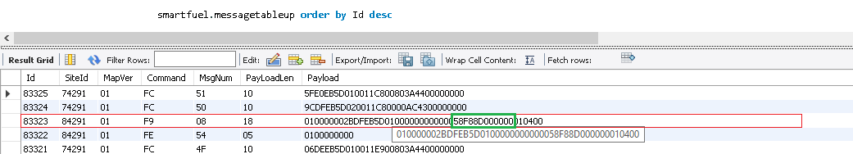
The Command 0xf9 is the command for the Rejection Report.

