Master Controller Hatting Series : Tank ATG Information
The Command that uploads the is 0xfc. There is a regular heartbeat configured that will send Tank information
Here is the raw data in the MessagetableUp.
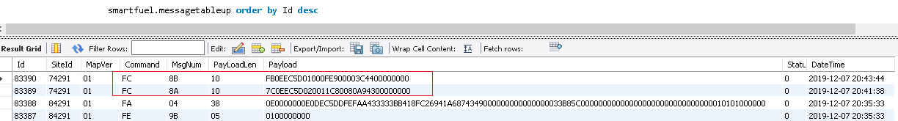

This is decoded into goes into two tables;
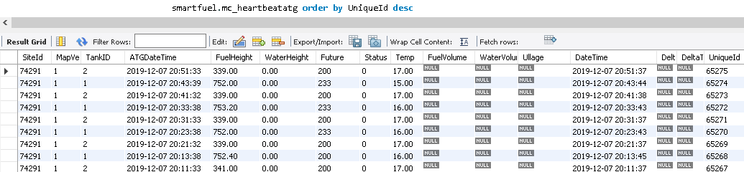
NB: the field with Nulls are not used and will be removed in future.
Now the field named “Future” is where certain events and errors are reported. Here what the bit positions represent;
TAGGING_COMM_ERROR 0x01 // Error on Tagging
ATG_COMM_ERROR 0x02 // Error on some ATG
UHF_COMM_ERROR 0x04 // Error on some UHF reader
NRF_COMM_ERROR 0x08 // Error on some NRF
GPS_COMM_ERROR 0x10 // Error on GPS data
WATCHDOG_RESET 0x20 // MC was reset from a Watchdog
BATTERY_CHARGER_FLAG 0x40 // Battery charger flag
GENERATOR_ON 0x80 // Generator is ON

The errors were part of the General heartbeat status and are also reported. This may change in the future.

The other table that data from the 0xfc command goes into is;
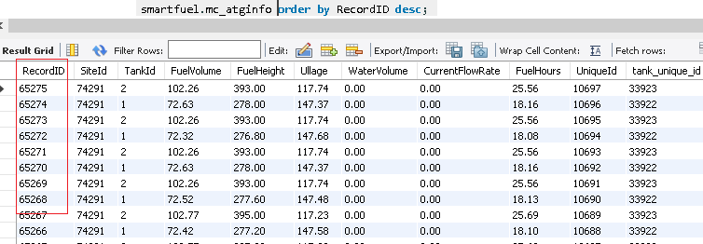
There is an additional table that decodes the Events and puts them into;

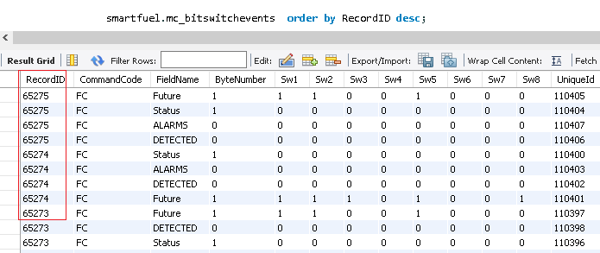
The recordID of both these tables is the UniqueID of the MC_ATGHeartbeat table.

The Field “FieldName” gives the field from MC_HeartbeatATG that is being decoded and the ByteNumber of 1 tells you its the first byte of that field.
Where ByteNumber is zero, these are event that are detected by data analysis, like monitoring a Flow rate.

This table below gives what each Switch (Sw1-Sw8) represent
