Training Centre document 2 17 Jan 2020
How to put the MID Test Rig into RS485 Mode (using the RS485 DB)
The Test Rig is configure with 4 MIDs using with one Tokheim, two Prowalcos and a Mechanical Pump.
This is brief guide on the steps to be taken to convert to RS485. The Configuration of the other MID switches are important but not covered here.
- Dipswitch1 – Set the Baudrate of Uart1 of the MID to 9600 (RS485 Mode)
Sw7 = OFF and Sw8 = ON (Hit the Reset button for changes to take)
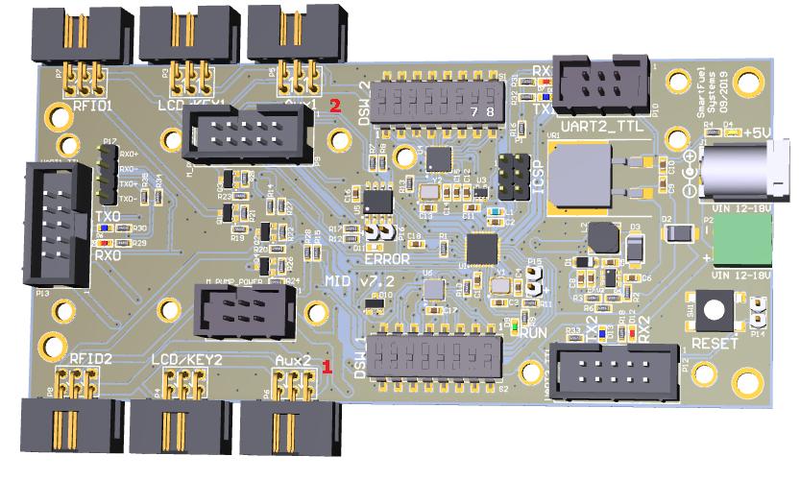
- Select the Port of the RS485 PC Adapter and set it in Pumps (not necessary to configure the comm. port for Tagging)

- PumpController.ini
A)
Set all Pumps to: PortSettings = 9600,N,8,1
For all Pumps that are configured.
Caution: All Pumps configured must have these same settings

B) This values must still be played with find a suitable setting for all Pumps
;Delay values
PumpsPollDelay = 60
TaggingPollDelay = 45

C) Configure the MIDDual1 Settings
MIDMODE must be set to 1

- Fit the RS485 DB to the MID and Start the PumpController

