Master Controller : Programming the PSU Board

- Connect uUSB and Pololu Programmer
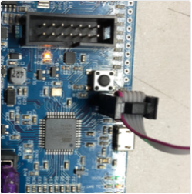
NB: the orientation of the cable

- Open Pololu Programmer and verify the following data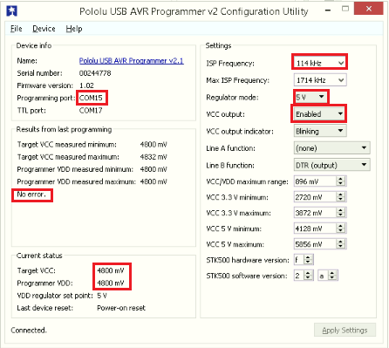
- Open AVR Dudes and follow the sequence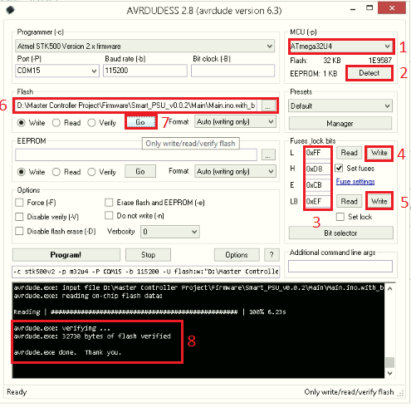

L = 0xFF
H = 0xD8
E = 0xCB
LB = 0xEF

