RFID v1.0 Programming and changes to the Board

Board and programmer connector:

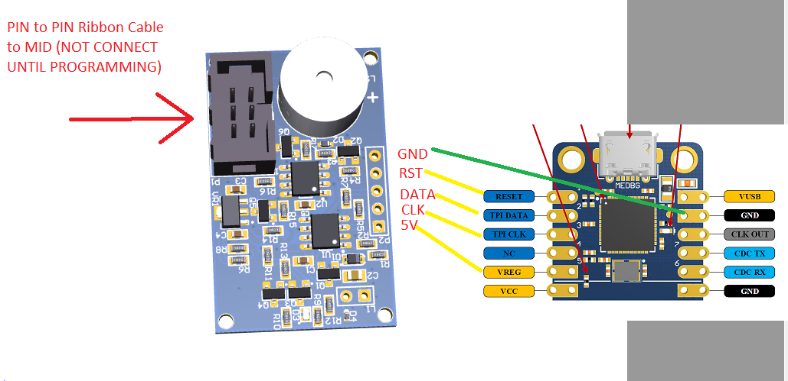
List of changes for HW V1.0
- 36 turns coil (30mm diameter or more)
- Add pull up to reset line
- Remove R3 and R11
- R1 must to be 0R
- R7 must to be 15k
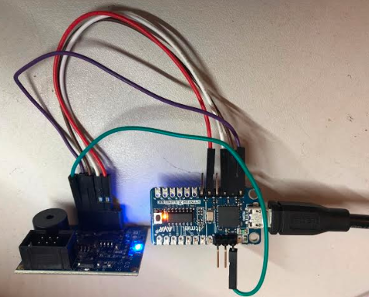

Programming sequence
- Open Atmel Studio
- Click on Device Programming
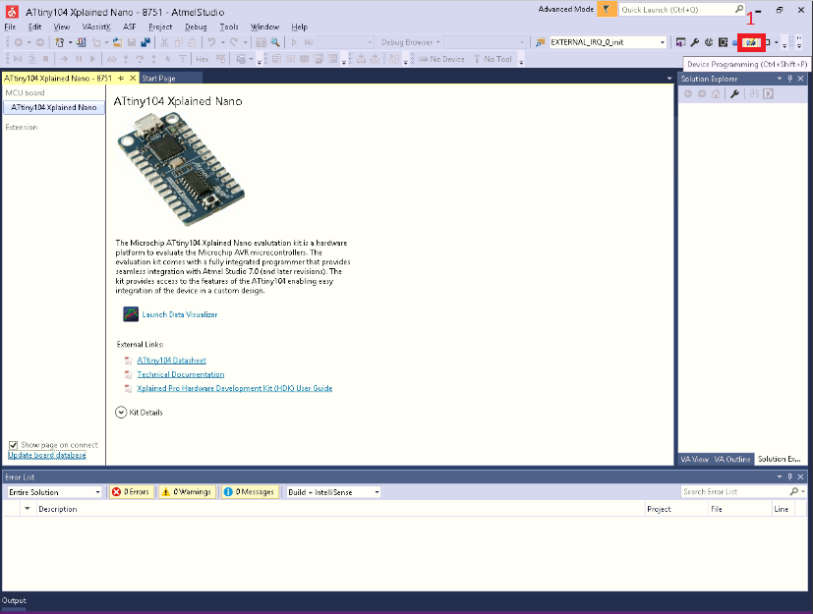
- Replace ATTiny104 by ATTiny102
- Click on “Apply”
- Read signature
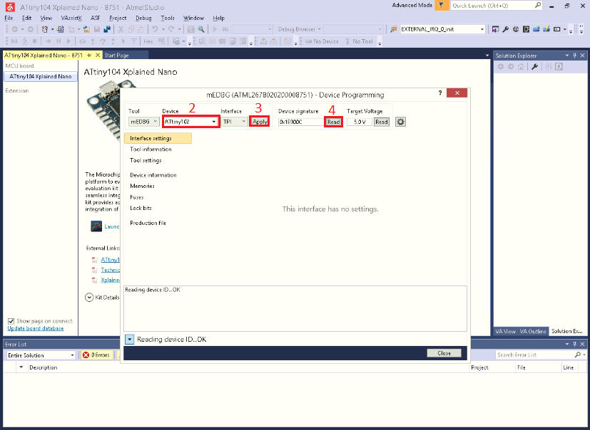
- Click on Memories
- Open the file located on RFID_Reader_v1.0\Release\RFID_Reader_v1.0.elf
- Click on Program
- Check the Verification after programming
