The Bill of Material fixes of the Homebase System
The Master Controller V1.2
This is link enables the Modem to be reset should it not respond like it should.
Link these two ends of these resistors with fine linking wire.
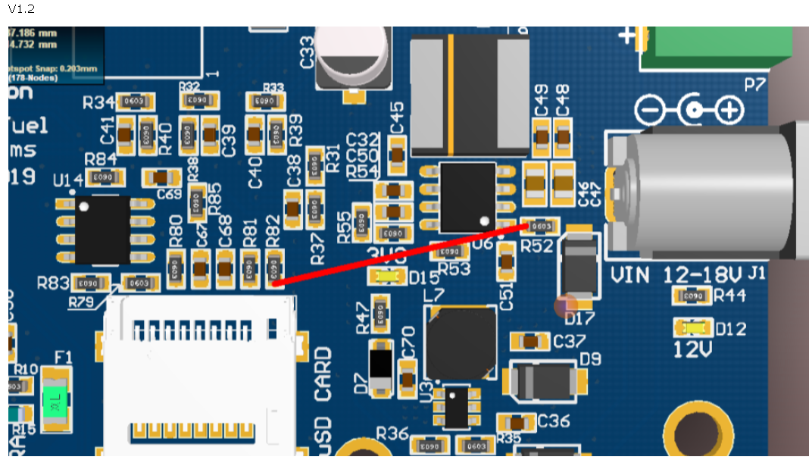

Display DB V1.1
Without this correction, the LCD Backlight will not appear. Remove some solder next to the affected leg and short the leg to the ground plane.
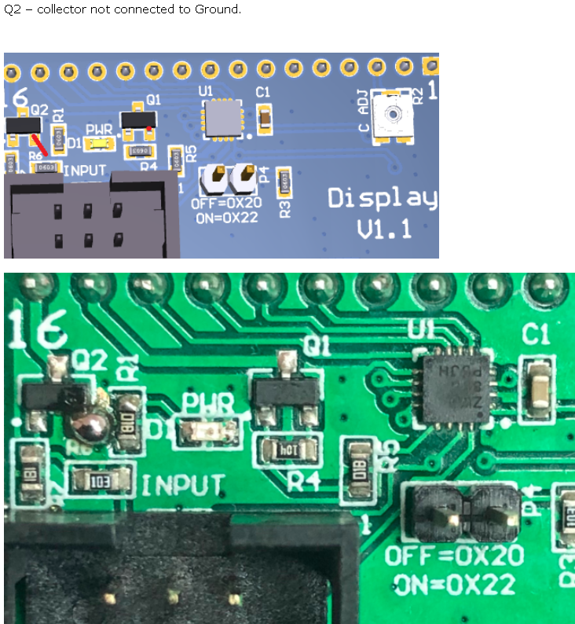

PSU and Battery Board V1.1
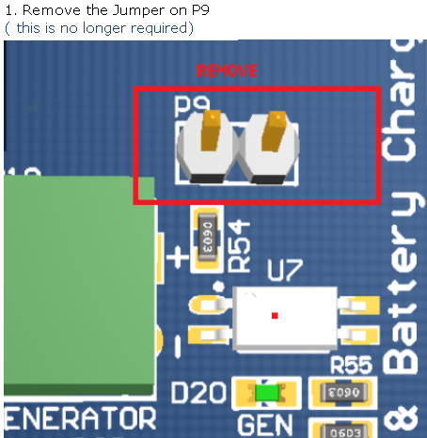These tracks must be carefully cut and be sure to check that connection, then link as described.
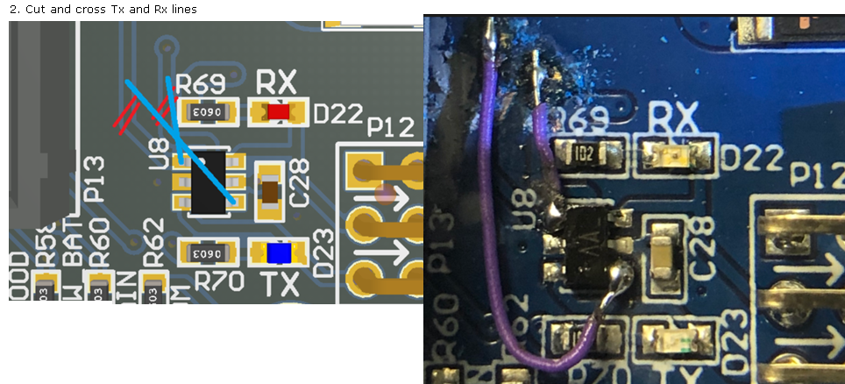

RFID DB V1.0
1) Add Strip Header Socket 2.54mm Pitch (5Way) to the component side.
2) Add 10K (through-hole) pull up to reset line (Solder Side)
3) Remove R3
5) Remove R11
6) R1 must to be 0R
7) Remove R7 and replace with 15k (0603)
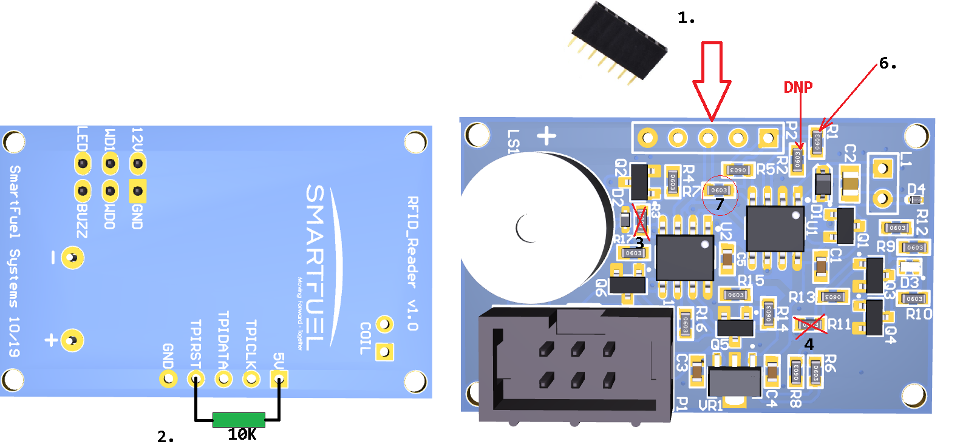
RS485 DB with P5 connector added.
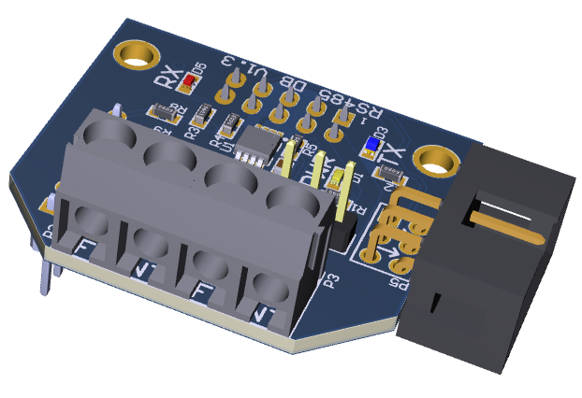

Mechanical Pump DB

This mod is likely required on all Installations. To get 5V on P2 to drive the Pulser, here is the mod. 