RFID Tag Reader Coil winding - Antenna
There are a few options on the coils sizes but we have uses (C) which is 39mm Diameter.
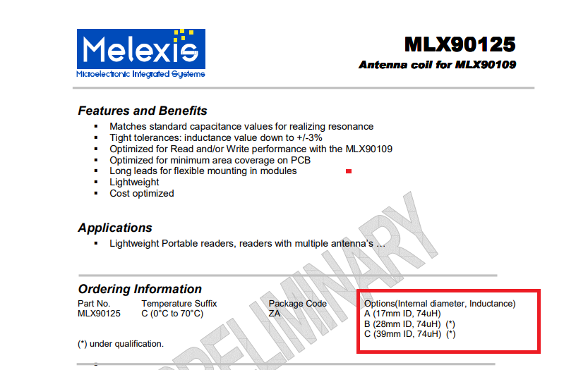

The other options can be explored if it comes to that. The wire we have is Grade1 0.2mm copper.

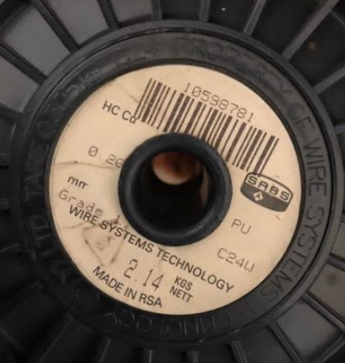
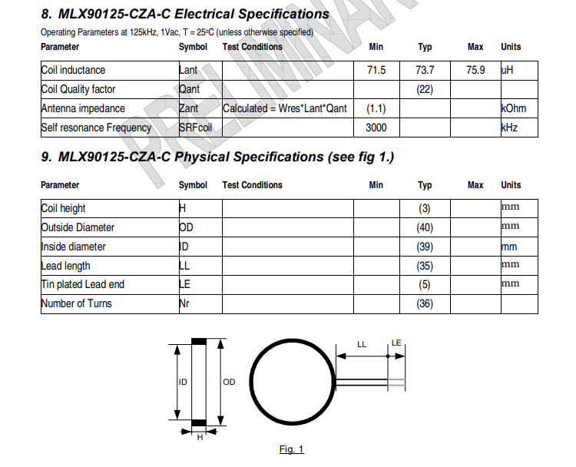
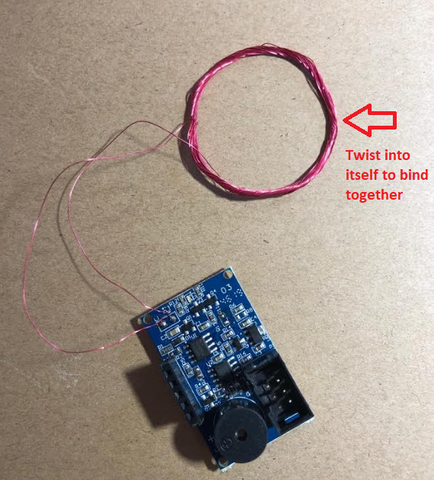
37 mm was used here and it worked well too, but let try to stick to the spec

