Master Controller data Cable to the Power Supply Unit
There is a ribbon cable that connects the MC to the PSU. Wire # 4 needs to be cut because the MC has 3V3 and the PSU supplies 5V on that line.
Alternately, it would be easier to remove that PIN from the PSU board on P12.
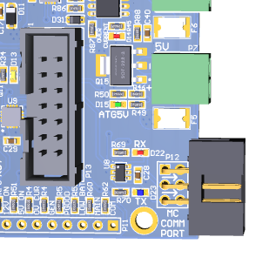
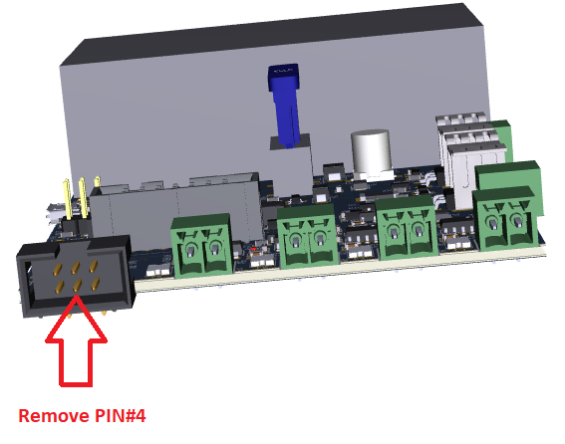
Use a long nose plier and remove this Pin without damaging the other pins

