Master Controller Basic Web Preliminary Setup Actions
Basic Action#1.
As a Super User add all cards to be used on the Web - using the method of the Web Loyalty System.
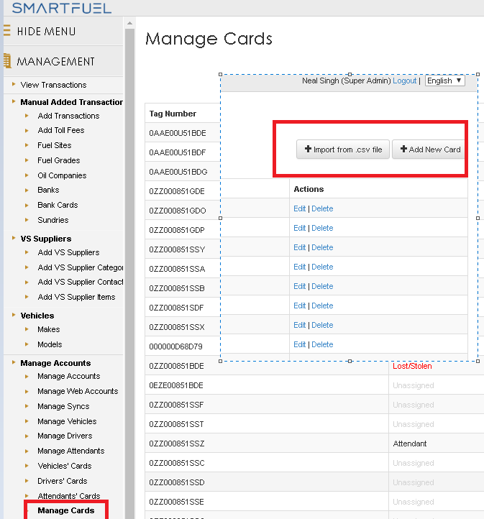

Basic Action #2
Add All makes and models of vehicles that are likely to be used in Farms and In South Africa in general
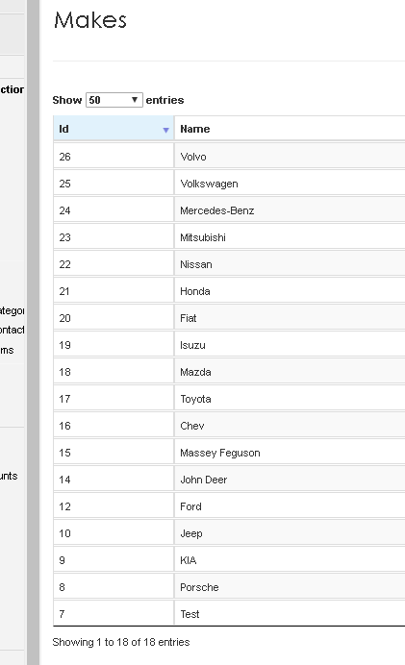
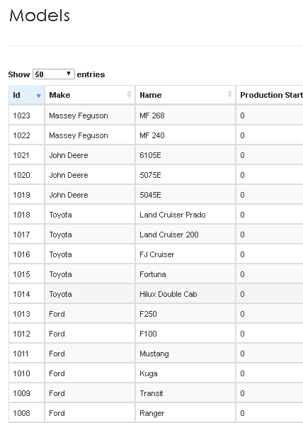
This can be an ongoing project that can be done from Reception

