Master Controller How to program using the Bossa Application

The IDE exports a binary file that can be programmed by the Bossa app.
NOTE: If this MC was previously programmed, you must clear the MC bootloader by shorting P1 with a wire;
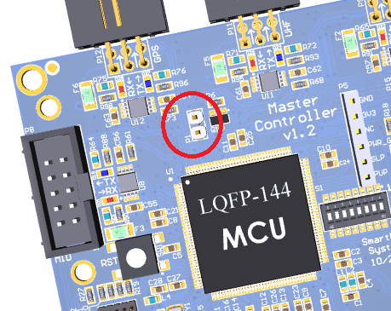
Once you connect the uUSB cable it will give port number in Device Manager prefixed with “AT91 USB”
The use the Bossa app and select these switches and Write.

