MID : Totalizer Fraud detection Standalone sale

The MECH DB is designed to fit a Hammond 1551P board (different to what we have in stock) .
Due to the space limitations, it can take to two small batteries one on the top and one on the bottom. The number of batteries will determine the period that we want the MID to run for to monitor potential fraud situations.
Battery Type: 3.7 Volts Lithium ion or Lithium Polymer
The current battery we have was source via Hanward (Cirket) and we got the best price from him.
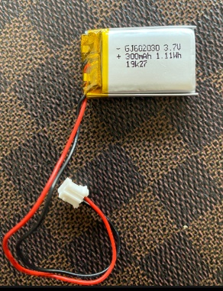
This is the battery that must connected either under or on the top of the MECH DB.
The wires should be cut short and soldered to te board as indicate by the arrows with Red to + and Black to -.
When the MID is not powered, the green RUN LED has an Off period of about 2 sec and an ON of about 200m/s. (in future this will be removed altogether so that there is no indication of power on the board.

With this in place with MID FW ver: 0.1.6D, the Master Controller will track pulser movement even if the system is power down.
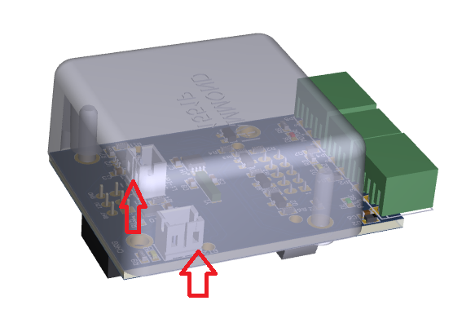
NB: This Hammond enclosure can be gotten from Communica – I have no data if it is an ex-stock item.

