Abest Technology Protocol Understanding - Standard Level Sensor
They have a Standard Device and an Enhanced device.
We have their Standard device. The enhanced device can log data and it does not fit what we need.
Its an RS485 / 12-24V device.
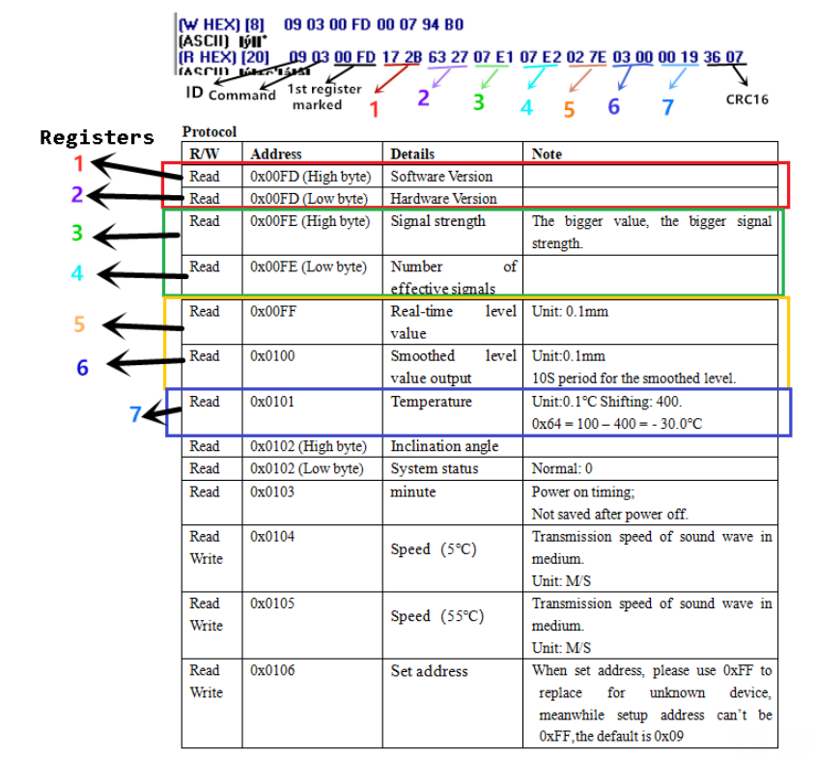

This is their Protocol doc
