Converting data to and from the MySQL Queue Tables
This is a description of the App that will run on the Server, that is required to convert the data into the format for the Master Controller and to put Master Controller’s data into a format that can be received by the current Web App. This data will be in the MySQL DB that has the 2 Queue Tables to manage the Traffic to and from the Master Controller.

Data Sent to the Master Controller
The specific records that need to be sent to Master Controller are put (by the Web app) into the same PUSH tables that are used to Sync data to the site by the SyncAppII.
The App would need to know which are the Homebase SiteID and this can be verified by looking into the ConfSites table on the Web DB for the records that have the Homebase Flag set;
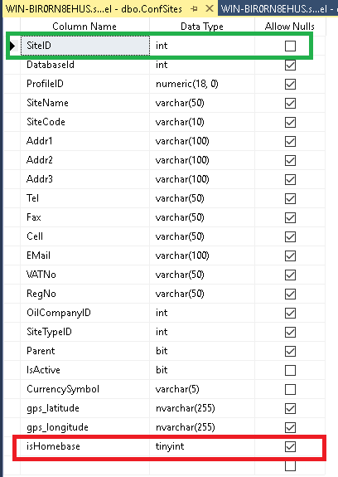
So the App would need to scan the Push table for the home base SiteIDs. Alternately, we can decide on a rule that all siteID from 100 000 to 200 000 are strictly for Master Controller Homebases Sites.

The Push Table
The Push Table is used by the SyncApp to identify the record that need to be Pushed to Site. The Sync Table is required by the SyncAppII to identify which fields etc need to be Pushed and which Table the Push applies to. We don’t need to use the Sync Table as the data we need to push is specific and we can insert all the other necessary data into the Push table
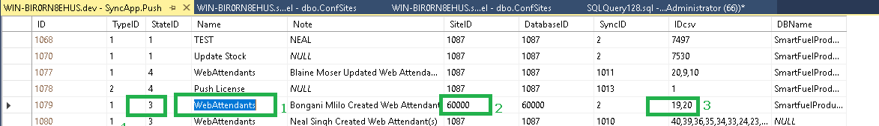
I will explain using the numbers above;
- Instead of giving a description of the PUSH, we can put the Table name here.
- SiteID must be a Homebase SiteID as determined by earlier discussion.
- IDcsv, give the PrimaryKey of the two records from the WebAttendants Table that need to moved to the Master Controller. (NB: It might be better that we send only single records – this can be discussed with the Web Team that work on the Web App).
- StateID: A value of 3, means it is ready to be “PUSH” ignore the rest. Once the Master Controller has confirm the successful sync, the StateID must be changed to 4 or 5 if it failed.
  - 1 - 'Push not ready'
  - 2 - 'Push ready'
  - 3 - 'Push pending'
  - 4 - 'Push complete'
  - 5 - 'Push failed'

Now with regards to how that data is converted, there are two ideas;
- It is done based on information coded from the MC_Download Spreadsheet regarding the information to be extracted for that Table.
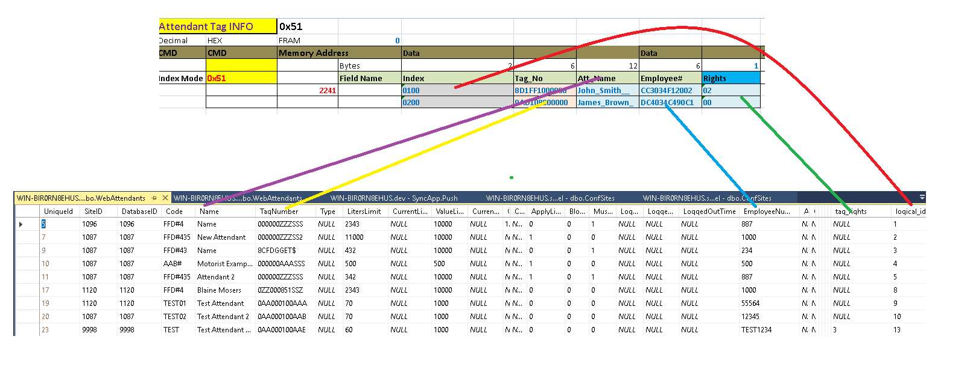

- The second idea was to use database tables;
There will be tables that have information about the conversion and these tables can be seen here;

In a special table will tell you look for the Table name and then which command code and how the conversion should occur from the Config Table
Table Name | Command Code | Config Table
WebAttendants | 0x51 | Config.Attendant_Info

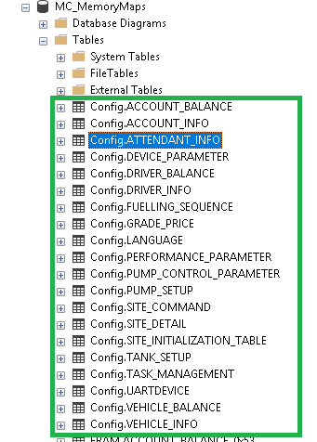

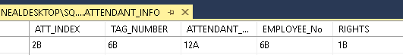
ATT_INDEX is 2B and all the data is in little endian format so if the Logical_ID in WebAttendants is 1, then the conversion to two byte little endian will ‘0100’.
12A says its 12 ascii characters that need to be converted and if there we only 6 characters, then the underscore value will be used to make it 12 characters (as seen in the names in the spreadsheet)
This will apply to the WebDrivers, WebAccounts and WebVehicles tables as well.
We just need to decide on the method you prefer to use, then we can work on creating that method.

Data from Master Controller to the Server
The following comes from the Master Controller
- Transactions
- Heartbeat
- Error Reports
- Rejection Notices
- And more
The Transactions need to be put into the Pos_transactions table on the web, the rest can go into its own table, but the key requirement is the transaction conversion.

