Master Controller How to set the Time 8 August 2019

Here is how the time is gotten and set on the MC

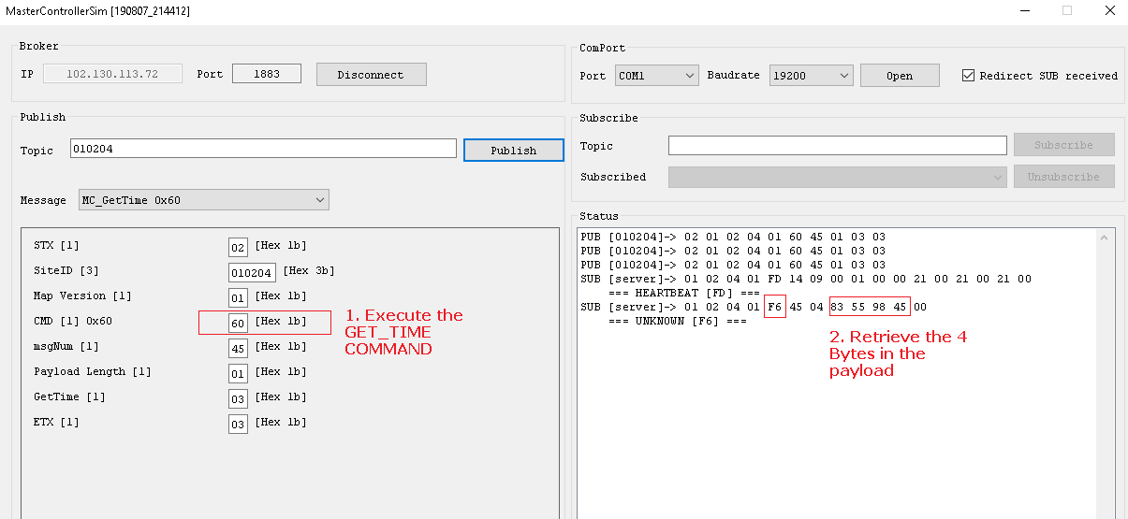
3. Put these Hex number in Little Endian into a Programming calculator to get the decimal TimeStamp.
83559845 become 45985583 (Little Endian)
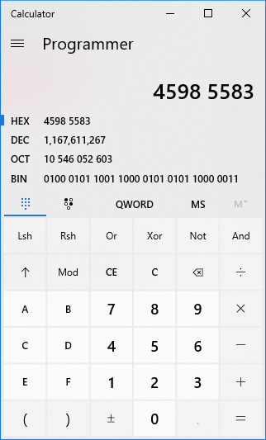
TimeStamp = 1167611267

4.
Use this link to convert the TimeStamp;
https://www.unixtimestamp.com/index.php
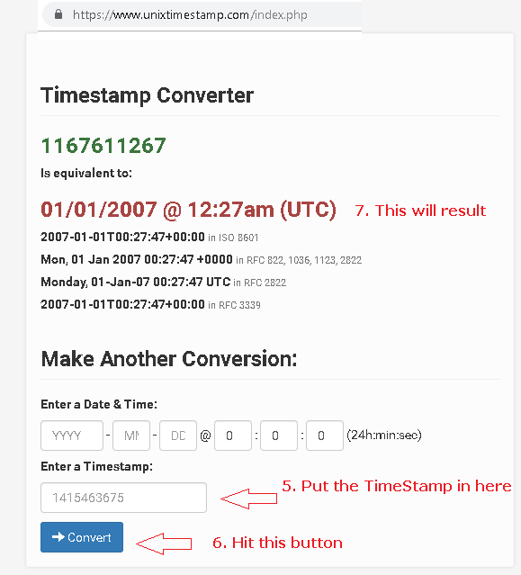
8. As you can see the time is incorrect and so we need to push the correct DateTime to the MC.
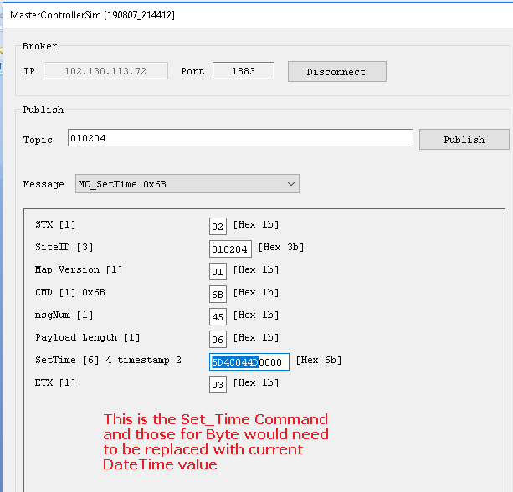

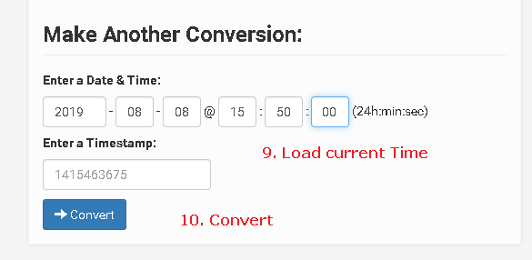
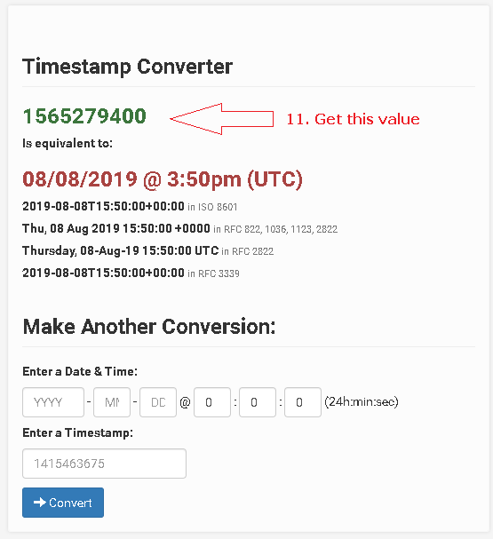
12. TimeStamp = 1565279400
13. Convert to Hex
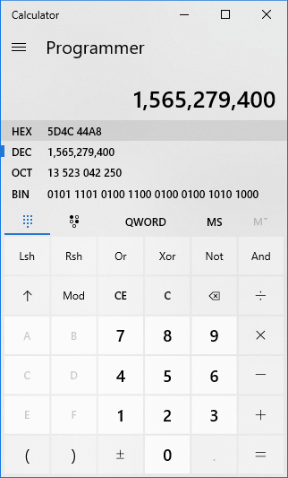
14. Now convert: 5D4C44A8 to Little Endian : A8444C5D
15. Send to the MC
